Present Perfect for Experience

Discuss your answers to these questions with a partner.
Have you been to Scotland?

Have you spent the night in a hospital?
Have you cheated in a test?
Have you worked in a shop?
Have you volunteered?

Just Yet Never
Before For Ever
Since Recently Already
This morning/afternoon/evening

- Which time expressions usually go at the end of a present perfect sentence?
________________________________________________________________________
________________________________________________________________________
- Which time expressions usually go after the auxiliary ‘have/has’ in a present perfect sentence?
______________________________________________________________________
______________________________________________________________________
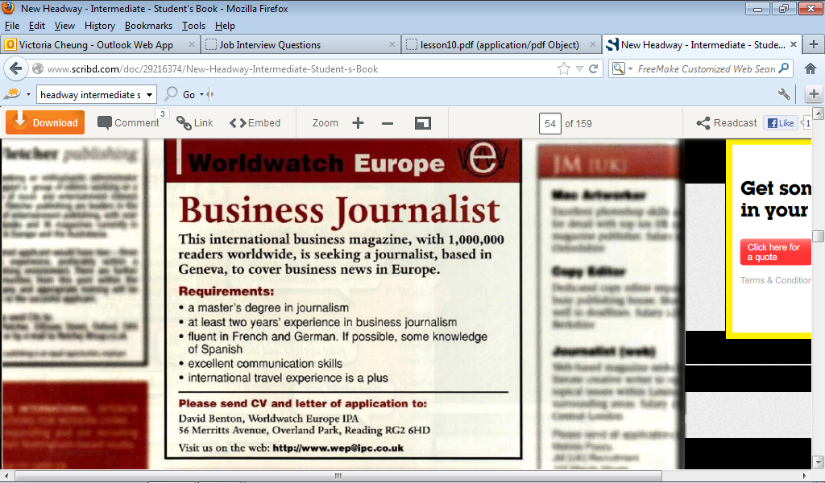
What job is being advertised?
______________________________
Where is the job?
______________________________
What skills and qualifications are they looking for?
_______________________________
How can you apply for the job?
_______________________________

The 3 Cs
‘CV’ is an acronym. What does it stand for?
________________________________________________________________________________
What ‘C’, describes someone who is applying for a job?
________________________________________________________________________________
What ‘C’ describes someone whose job is to report the news?
________________________________________________________________________________

- You work for the company: Worldwatch Europe. In pairs, think of 5 questions you could ask a potential candidate using the PRESENT PERFECT.
For example: Have you worked as a journalist before?

- ________________________________________________________________________
- ________________________________________________________________________
- ________________________________________________________________________
- ________________________________________________________________________
- ________________________________________________________________________
- One of the candidates who applied for the job has been called in for an interview. Read the interview, can you find similar questions to yours? Underline them.

Interviewer: Who do you work for at the moment, Nancy?
Nancy: At the moment, I work for the BBC World Service. Currently, I am the German correspondent.
Interviewer: Ah, and how long have you worked for the BBC?
Nancy: I’ve been with the BBC for five years. Yes, exactly five years.
Interviewer: And how long have you been their German correspondent?
Nancy: For two years.
Interviewer: And what did you do before the BBC?
Nancy: I worked as an interpreter for the EU.
Interviewer: As you know, this job is based in Geneva. Have you ever lived abroad before?
Nancy: Oh yes, I have.
Interviewer: And when did you live abroad?
Nancy: Well, I was born in Argentina and I lived there until I was eleven when we moved to London. Also, I lived and worked in Brussels for two years when I was working for the EU. That was before I started working for the BBC here in London.
Interviewer: That’s interesting. Have you travelled much?
Nancy: Yes indeed. I’ve travelled all over western and eastern Europe, and I’ve also been to many parts of South America and I have just returned from a trip to Indonesia. I’ve yet to visit Geneva though.
Interviewer: Tell me about your studies.
Nancy: Well, at university I studied French and German. More recently, I’ve started a part-time degree in politics. I’ve already got a degree in International Relations, but I’ve always enjoyed studying very much.

Match the beginnings and ends of the sentences to make them true for Nancy. Use the interview to help you BUT you will not find all the answers there. You will have to work out some of the answers yourself.
Put the events in order along the time line. The first one has been done for you.
a. She worked in Brussels 1. when she was at University
b. She has been married 2. since her son was born four years ago.
c. She was born 3. for the last 5 years.
d. She went to boarding school in England 4. three times.
e. She has worked for the BBC 5. in Argentina in 1959.
f. She married for the first time 6. last year.
g. She hasn’t worked abroad 7. for two years, from 1989 to 1991.
h. She married for the third time 8. when she was twenty-one.
i. She studied French and German 9. from 1970 to 1977.

PAST PRESENT FUTURE
Nancy was born in Argentina in 1959.

Find a job advertisement that you are interested in, in one of the newspapers. Give the advertisement to your partner.
Write 5 questions (using the present perfect and past simple) to find out if your partner is suitable for the job they have chosen.
For example: How long have you worked with children?

- ____________________________________________________________________________________________________________________________________________________
- ____________________________________________________________________________________________________________________________________________________
- ____________________________________________________________________________________________________________________________________________________
- ____________________________________________________________________________________________________________________________________________________

- ____________________________________________________________________________________________________________________________________________________

Ask your partner the questions and then, decide if they should get the job!

